Programming Project 1

Jasmine Roberts

Bowie State University

CTEC 445-1010

Dr.Haydar

September 7, 2024

**Introduction**

In Programming Project 1, I was instructed to develop a model to simulate IoT devices, which will simulate the transmission of a secure simulated health care data. This project was created as a guide to be able to understand IoT device data in real time, and encryption. This program uses safe encryption to secure data. Although, there is part of the code that shows decryption as an example of what the results would look like if the information was in a decrypted state.

# Breaking down the given code vs. Revised Code

Given Code:

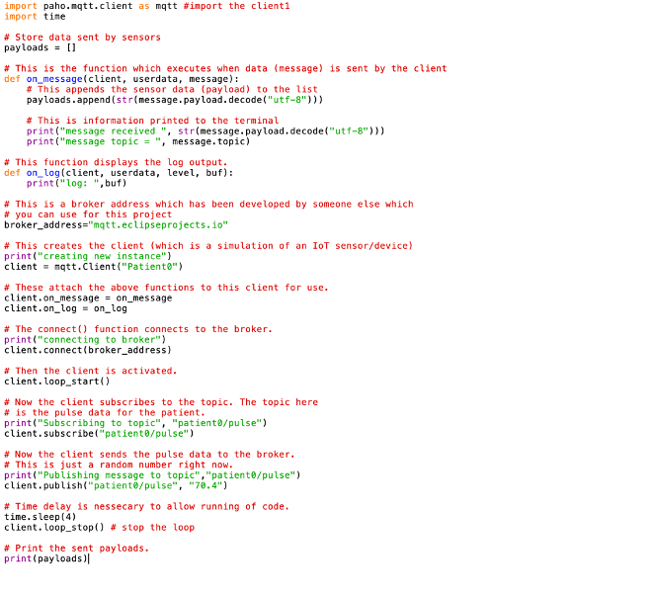

Revised Code:

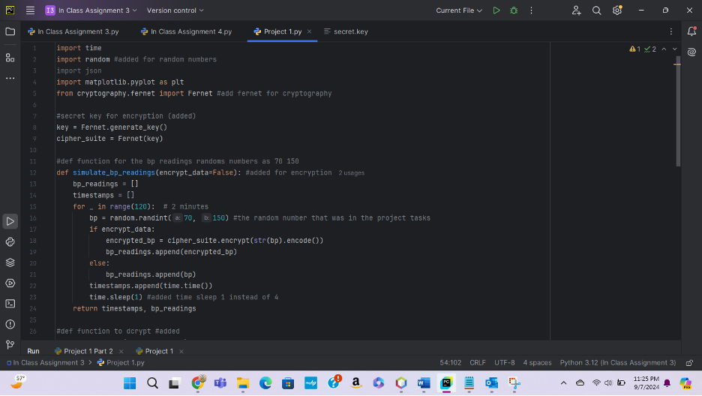

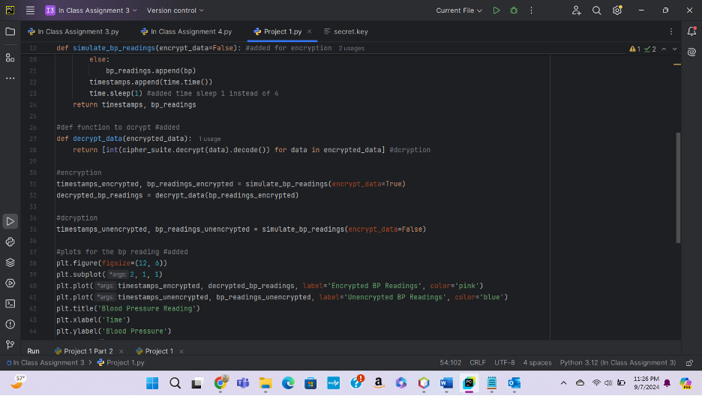

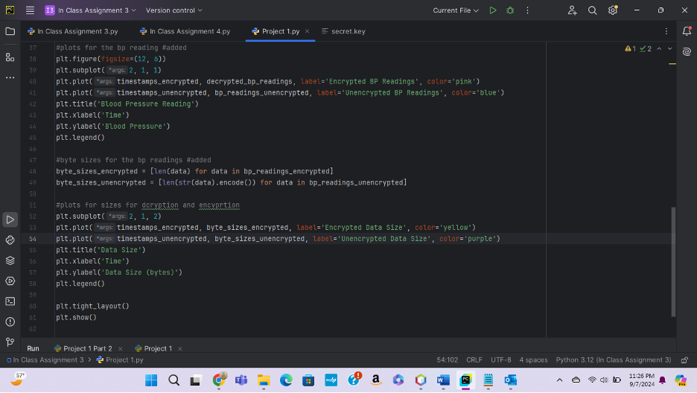

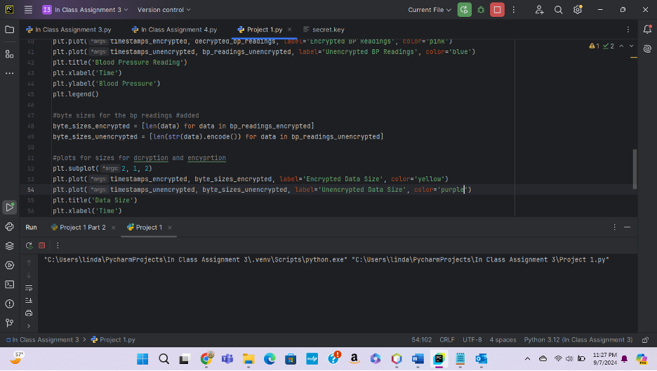

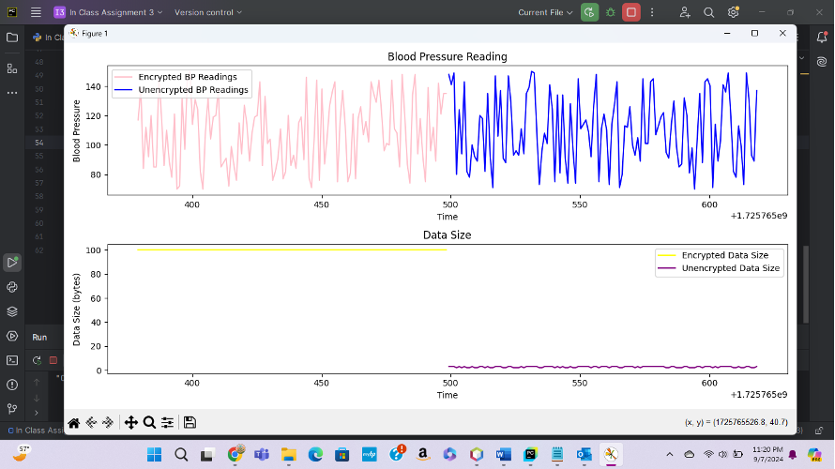

Explnation of the Revised Code:

**In order for my revisons to complie in Pycharm I installed:**

- Fernet

- Crytopgrpahy

- Phao-mqtt

- Mesaage

- Json

- Random

I mostly revised the entire code from the starter.py, because I was having some errors with the following:

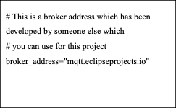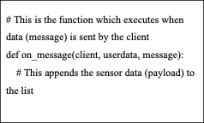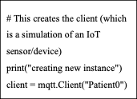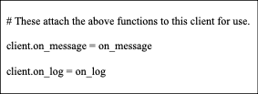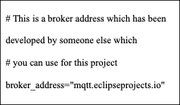

def on_message function would give me most of the error, expressing that “Client wasn’t a factor or defined” and “on message” wasn’t defined, pycharm instructed me to change the entire function.

That’s where I constructed:

- def simulate_bp_readings which does equal the same things a def on_message because they are both functions to read data.

I also constructed the function for encryption, ( encrypt_data=False), and then I typed in the given number from the Project devliables (70 and 150) as:

- bp = random .randint(70, 150)

The broker address kept sending back an error.

Additions to the entire code

I implemented the following:

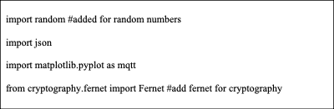

The starter coder only had paho and time, we stilll needed some more components to import.

Random libary is set for the random number that were used for the blood pressure

Json is a encoder and decoder for storing and exchanging the data

Matplotlib as mqtt is for the visualizations and animations we created ( the blood pressure simulator)

Fernet is for encryption such as the data. It is also known as symmetric encryption

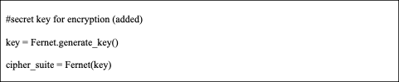

The starter code did not have a secret key generator function, we needed this function in order for the code to be “encrypted” . Fernet was implemented for encryption

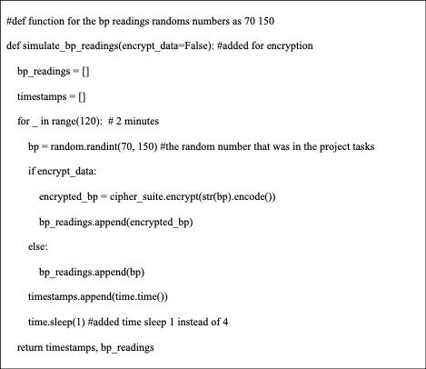

The starter code displayed:

def on_message(client, userdata, message):

# This appends the sensor data (payload) to the list

payloads.append(str(message.payload.decode("utf-8")))

# This is information printed to the terminal

print("message received ", str(message.payload.decode("utf-8")))

print("message topic = ", message.topic)

I was having many errors with def on_message function so I constructed the def simulate and def bp readings to receive data and analyze it, and to put it in a log . Def on_message and Def bp readings are similar because they both read the bp data.

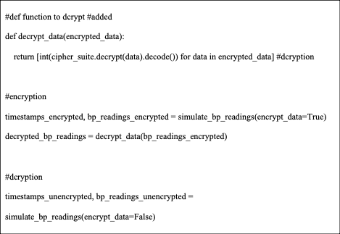

The given code, did not have any encryption functions inside of it so I constructed “def_dcrypt_data” so the data can encrypt itself, and “time_stamps”, so each variable on the code can be encrypted , I also added functions for encryption such as “unencrypted” because I was instructed to supply encryption and decryption

Plots:

Below are the plots I constructed for the structure of the simulated BP Readings/Pulse REadings, it consists of what colors the line graphs are going to be, the title, and the encryption/ decryption in one figure. Also, the fig size, time, blood pressure data and byte size. This is considered the structure and labels of the figure we are making.

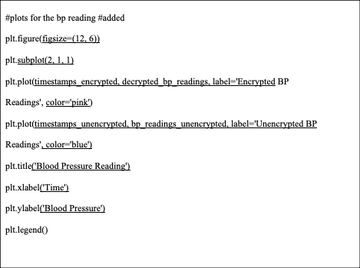  
#byte sizes for the bp readings #added

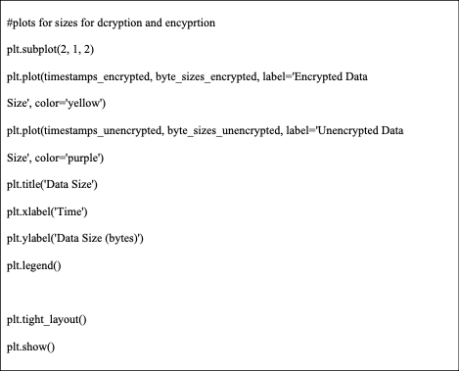

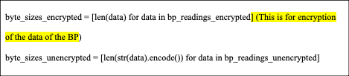

Explain how you can expand upon this simulation in a future project. What parts of the code can you adjust to make it more realistic?

In order to make the code more realistic is putting my real Blood Pressure readings into the code and letting it simulate. That would be more realistic because real blood pressure readings will be implemented into the code.